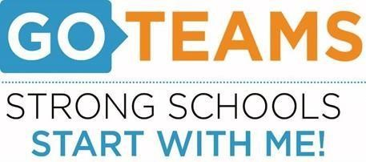
School | Date | Time | Location
BEST Academy (6-12) | 2/8/22 | 5:00pm | Zoom Call
Notice Prepared By: Dr. Timothy Jones Date Posted: February 8, 2022 Revised: 2/7/22

Meeting Agenda
(Agenda may be amended)
This meeting will allow for Public Comment
Join Zoom Meeting: https://atlantapublicschools-us.zoom.us/j/82681561524?pwd=WVh1TlViejE1aHhtNC8xU0NjR2R3Zz09
- START Recording
- Call to Order: 5:06 by Dr. Jones
- Roll Call; Establish Quorum (Dr. Jones, Dr. Williams, Dr. Gillard, Mr. Battles, Ms. Kurtz, Ms. Cavett, Mr. Fling, Mr. Norman) Guest: Dr. Barnett ABSENT:
- Action Items
  - Approval of Agenda - Yes
  - Approval of Previous Meeting Minutes – Yes (Cavett/Fling)
  - Budget SY 22-23 in review - Dr. Jones gave a tentative overview of the budget, however, nothing is written in stone until after the district wide budget meeting
- Strategic Plan Review –
- Dr. Gilliard asked if there were any thoughts of BEST being an Early College
- Dr. Barnett asked if our school priorities were aligned with APS the 5 (#4 – Effective teacher in every classroom
- 6C – mobile app (Appademics) additional information to be shared at March meetingand Brag board (Dr. Williams)
- Discussion Items - Budget
Strategic Plan
- Information Items -
A. Test Talk ( Dr. Jones gave an overview))
B. Anti-Gun Violence Initiative – The 100 Black men of Atlanta sponsored an anti-gun contest open to
BEST and students at other Atlanta High Schools, results forthcoming
C. TEM Update - Dr. Jones gave a brief overview of the TEM model
D. Winter Break February 17-21

- Public Comments – N/A
- Announcements
  - Next meeting March 10, 2022
- Adjournment 6:05pm

